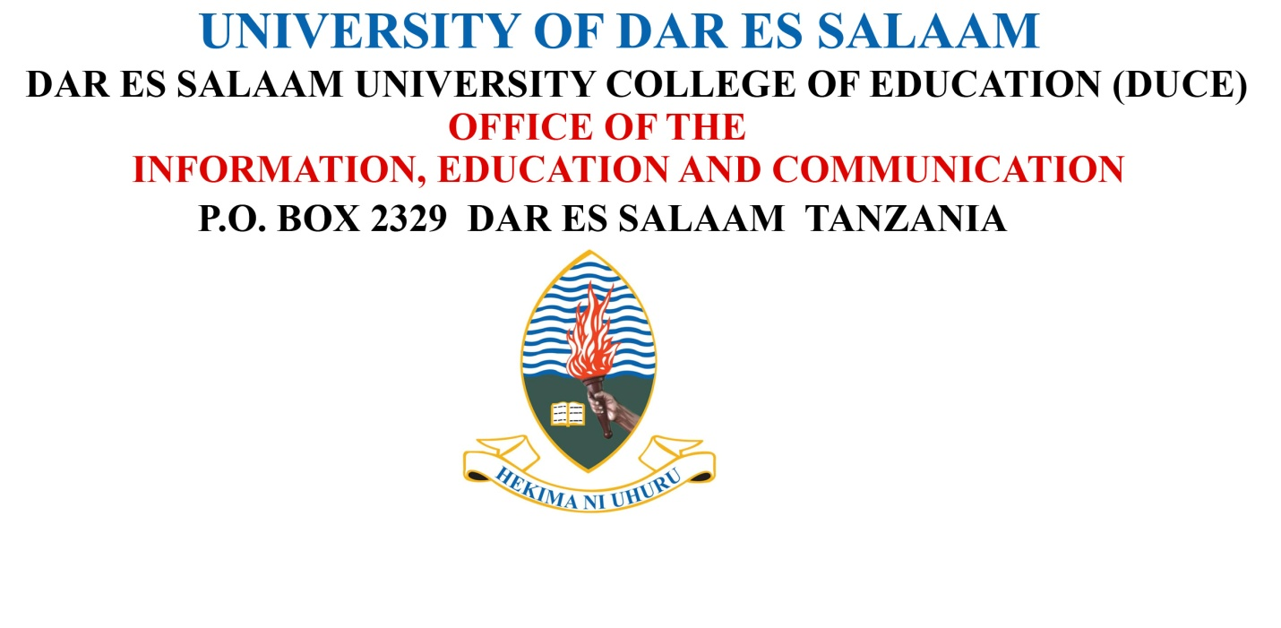

Email: pro@duce.ac.tz
Website: www.udsm.ac.tz
www.duce.ac.tz
Phone: +255 73 516 9858
+255 78 716 9858

30th April 2020
PUBLIC NOTICE
BEST WORKERS OF THE YEAR
The Acting Principal of the Dar es Salaam University College of Education (DUCE), Prof. Stephen Oswald Maluka, has the pleasure to announce to the entire DUCE Community the College overall Best Worker and Departmental Best Workers of the Year 2019/2020 as follows:

A: The Overall College Best Worker

Dr. Dativa Joseph Shilla
Lecturer and the Head
Chemistry Department
Faculty of Science

Dr. Dativa Joseph Shilla is a Lecturer in the Faculty of Science and Heads Chemistry Department since 19th November 2018. She is known as “someone who has the ability to inspire fellow academicians in research and publications.”As the Head of Department, she has worked to advocate achievement of the departmental objectives and assisted other members of the Department and the Faculty at large to perform their duties diligently and achieve the overall Faculty objectives. In collaboration with other scholars, she has won the following projects:

- “Towards reducing human exposure to combustion-derived pollutants in urban areas of the Lake Victoria watershed; Improvement of indoor air quality in selected urban communities of Kampala and Mwanza.”

- Assessment of the Ecological Aspects of Microplastic Pollution in Dar es Salaam, Zanzibar and Mombasa Coastal Marine Environments (MICROMARE).

- “Microplastic Distribution and Reconstruction of its Pollution History in Msimbazi River Catchment, Dar es Salaam.”

- “Reducing Marine Plastic Wastes in Two Major Tanzanian Cities: Social awareness and Co-responsibility.”

Dr. Shilla has also facilitated the College to produce sanitizersto be used within the College and elsewhere during the time of COVID-19 pandemic prevalence in the Country and the world at large.

B: Departmental Best Workers

No. | Name | Designation | Department
 | Dr. David Sylvester Kacholi | Senior Lecturer | Office of the Dean, Faculty of Science and Chemistry and Department
 | Mr. MasambaMuhindi Kweba | Principal Clinical Officer II | Dispensary
 | Mr. Laurian Philip Wajimila | IT System Administrator II | ICT
 | Mr. Miraji Mohamed Salehe | Bursar | Finance and Accounts
 | Mr. Omary Mohaned Mshana | Library Assistant II | Library
 | Ms. Riziki Danstan Luoga | Principal Games Tutor I | Students Services
 | Ms. Clotide Mathew Luoga | Office Management Secretary II | Human Resource Management
 | Mr. Bilshan Wilson Odero | Senior Assistant Supplies Officer I | Principal’s Office (Information, Education and Communication Unit, Internal Audit Unit, Legal Unit, Quality Assurance Unit, Gender Centre and Assistant to Principal, Procurement Management Unit)
 | Ms. Rehema Eliawonyi Ngowi | Senior Administrative Officer I | Office of the Dean, Faculty of Humanities and Social Sciences; and Economics and Geography department
 | Mr. Mohamed Salehe Omari | Artisan I | Estates
 | Dr. Gasper Godson Mwanga | Lecturer | Physics, Mathematics and Informatics Department (PMI)
 | Dr. Maregesi Manyonyi Machumu | Lecturer | Educational Psychology and Curriculum Studies Department (EPCS)
 | Dr. Frank Jones Mateng’e | Lecturer | History, Political Science and Development Studies Department
 | Ms. Rehema Meshack Mdoe | Education Officer I | Demonstration Secondary School Department  Demonstration Pre-School and Primary Schools Department
 | Mr. Baraka Bitebu Mding’i | Auxiliary Police | Transport and Auxiliary Police Department
 | Dr. Loveluck Philip Muro | Lecturer | Languages and Literature
 | Mr. Mathias John Punguti | Senior Office Attendant III | Office of the Dean, Faculty of Education; Educational Foundations, Management and Lifelong Learning (EFMLL); Special Education Unit; Demonstration Schools Coordination Unit; and Teaching Practice Coordination
 | Dr. Dativa Joseph Shilla | Lecturer | Office of the Dean, Faculty of Science and Chemistry Department
 | Mr. Edson Nestory Tirubonwa | Senior Administrative Officer I | Deputy Principals Department (Deputy Principal Academic; Deputy Principal Administration, Coordinator of Postgraduate Studies and Research Unit, Coordinator of Undergraduate Studies Unit, Education Research and Innovation Directorate Planning Investment and Resource Mobilization Department)
 | Mr. Franco Michael Mafuru | Teacher I | Demonstration Pre-School and Primary Schools Department

We Congratulate all of the Best Workers on the awards

Issued by,
Information, Education and Communication Office - DUCE

